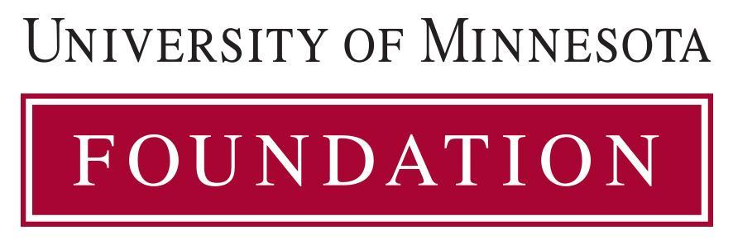

Therese Zink Student Narrative Award

Information on Nominee

Full Name:

Home Address:

Phone Numbers:

E-mail Address:

***********************************************************************************

Nominee Name: Date:

Deadline: February 15, 2024

Submit the application form and all application materials electronically as a single PDF:
- Manuscript (substantially completed or completed – no abstracts or grant proposals)
- Nominee’s resume/CV

Submit via mail, email, or in person to:
University of Minnesota Medical School
ATTN: Elisabeth Arendt
Phillips Wangensteen Building
Department of Family Medicine and Community Health
516 Delaware Street SE
Suite 6-100 | MMC 381
Minneapolis, MN, 55455
mse@umn.edu

